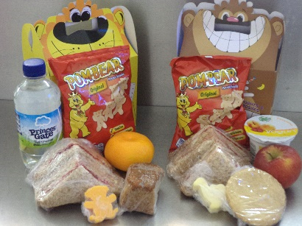

Lunch Box Menu £2.50
Please tick your choice

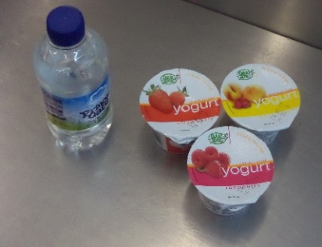 | CHOICE 1  - Still water  OR  - Fruit yoghurt
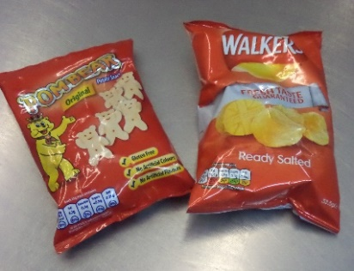 | CHOICE 2  - Pom Bears  or  - Plain crisps
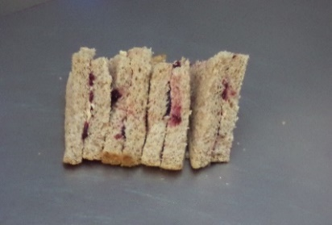 | CHOICE 3  - Marmite sandwich  or  - Cheese sandwich  or  - Jam sandwich
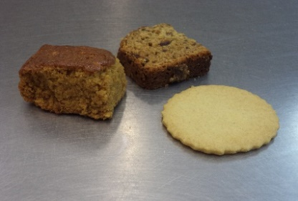 | CHOICE 4  - Homemade fruit loaf  or  - Homemade biscuit
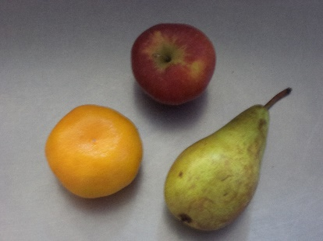 | CHOICE 5  - Apple  or  - Satsuma  or  - Pear
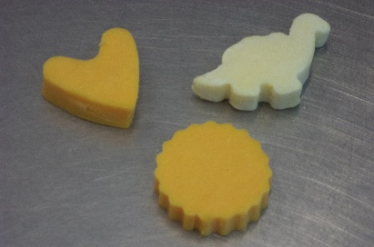 | Piece of cheese included with each lunch box

